**Homework 4**

Remember that your programs must read the data from the text files exactly as they appear. You may not edit the text files to make them more convenient for SAS. Turn in the code, log file and output. If any of these 3 items is missing then you will not be graded for that question. Use the snipping tool instead of screen shots and make sure the font is large enough for me to read.

1. Refer to the SOCCER dataset. Write a SAS program which creates a SAS dataset and writes each player’s name and jersey number to a text file called SOCCDATA.TXT on your USB. The text file should look like this:

Danielle Bass wears Number 11 .

Erin Baxter wears Number 23 .

Keisha Bell wears Number 5 .

Christie Brady wears Number 8 .

Etc.

Turn in a copy of the SAS program and a printout of the file SOCCDATA.TXT. Make sure that your program reads jersey number 00 correctly.

Code:

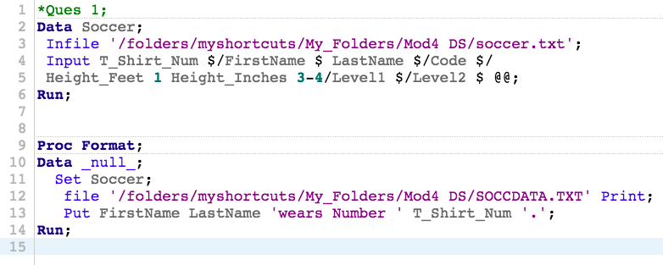

Log:

|  |
| --- |
| 1 OPTIONS NONOTES NOSTIMER NOSOURCE NOSYNTAXCHECK;  72  73 *Ques 1;  74 Data Soccer;  75 Infile '/folders/myshortcuts/My_Folders/Mod4 DS/soccer.txt';  76 Input T_Shirt_Num $/FirstName $ LastName $/Code $/  77 Height_Feet 1 Height_Inches 3-4/Level1 $/Level2 $ @@;  78 Run;    NOTE: The infile '/folders/myshortcuts/My_Folders/Mod4 DS/soccer.txt' is:  Filename=/folders/myshortcuts/My_Folders/Mod4 DS/soccer.txt,  Owner Name=root,Group Name=vboxsf,  Access Permission=-rwxrwx---,  Last Modified=01Mar2018:20:47:14,  File Size (bytes)=4608    NOTE: 192 records were read from the infile '/folders/myshortcuts/My_Folders/Mod4 DS/soccer.txt'.  The minimum record length was 22.  The maximum record length was 22.  NOTE: SAS went to a new line when INPUT statement reached past the end of a line.  NOTE: The data set WORK.SOCCER has 32 observations and 8 variables.  NOTE: DATA statement used (Total process time):  real time 0.00 seconds  cpu time 0.00 seconds      79  80  81 Proc Format;    NOTE: PROCEDURE FORMAT used (Total process time):  real time 0.00 seconds  cpu time 0.00 seconds    82 Data _null_;    83 Set Soccer;  84 file '/folders/myshortcuts/My_Folders/Mod4 DS/SOCCDATA.TXT' Print;  85 Put FirstName LastName 'wears Number ' T_Shirt_Num'.';  86 Run;    NOTE: The file '/folders/myshortcuts/My_Folders/Mod4 DS/SOCCDATA.TXT' is:  Filename=/folders/myshortcuts/My_Folders/Mod4 DS/SOCCDATA.TXT,  Owner Name=root,Group Name=vboxsf,  Access Permission=-rwxrwx---,  Last Modified=01Mar2018:21:10:51    NOTE: 32 records were written to the file '/folders/myshortcuts/My_Folders/Mod4 DS/SOCCDATA.TXT'.  The minimum record length was 27.  The maximum record length was 35.  NOTE: There were 32 observations read from the data set WORK.SOCCER.  NOTE: DATA statement used (Total process time):  real time 0.00 seconds  cpu time 0.02 seconds      87  88  89 OPTIONS NONOTES NOSTIMER NOSOURCE NOSYNTAXCHECK;  102 |

Results: - Output SOCCDATA.TXT File:

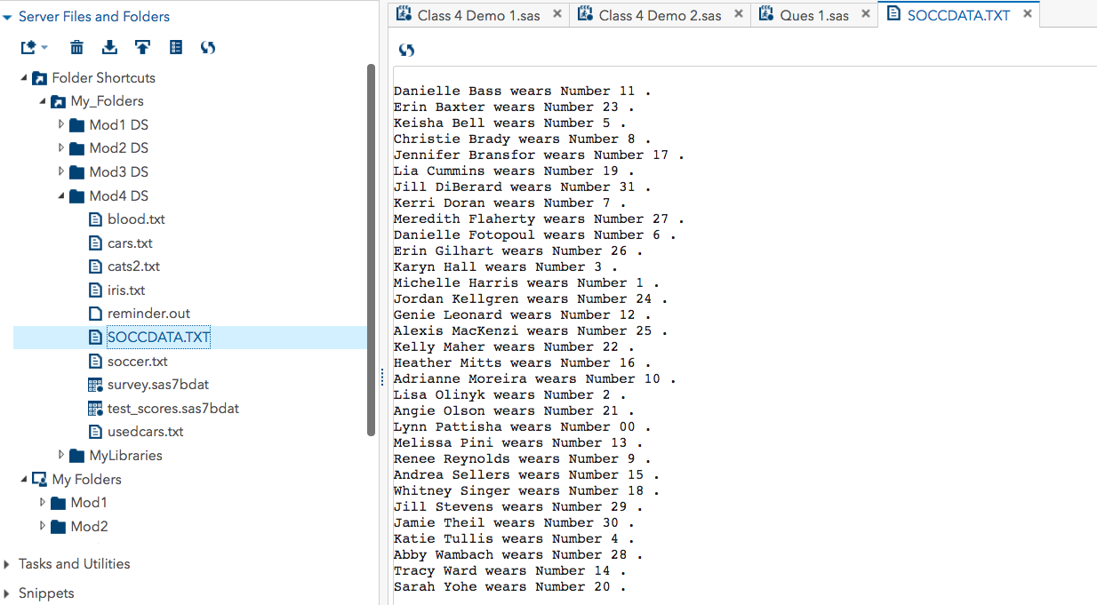

(Note: I am not able to insert the text copy of the output file SOCCDATA.TXT as I got some update issue with my MS Office. Therefore, I have attached the screenshot of the file below.)

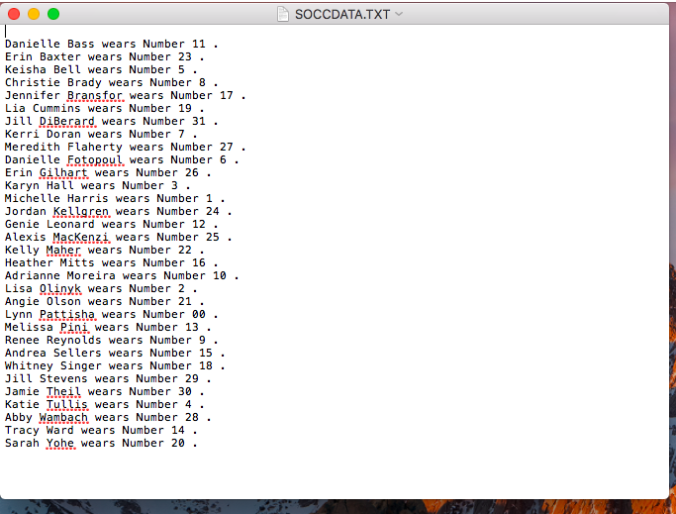

1. Refer to HOCKEY dataset. Write a SAS program which creates a SAS dataset and writes the date, Ohio State’s score, opponent’s name and the opponent’s score to a text file called HCKYDATA.TXT on your USB. Use an appropriate format for the date. The text file should look like this:

10/10/1997: Ohio State 5 , Toronto 0

10/18/1997: Ohio State 0 , Miami 3

10/24/1997: Ohio State 2 , Merrimack 7

10/26/1997: Ohio State 5 , Merrimack 3

Etc.

Code:

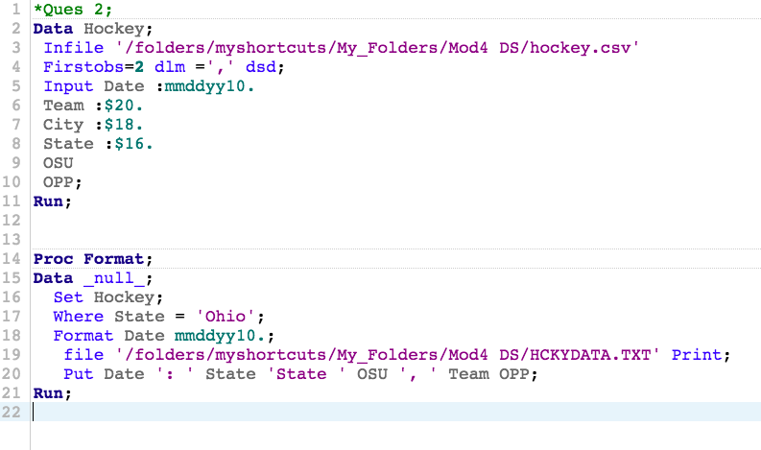

Log:

|  |
| --- |
| 1 OPTIONS NONOTES NOSTIMER NOSOURCE NOSYNTAXCHECK;  72  73 *Ques 2;  74 Data Hockey;  75 Infile '/folders/myshortcuts/My_Folders/Mod4 DS/hockey.csv'  76 Firstobs=2 dlm =',' dsd;  77 Input Date :mmddyy10.  78 Team :$20.  79 City :$18.  80 State :$16.  81 OSU  82 OPP;  83 Run;    NOTE: The infile '/folders/myshortcuts/My_Folders/Mod4 DS/hockey.csv' is:  Filename=/folders/myshortcuts/My_Folders/Mod4 DS/hockey.csv,  Owner Name=root,Group Name=vboxsf,  Access Permission=-rwxrwx---,  Last Modified=01Mar2018:21:26:10,  File Size (bytes)=1701    NOTE: 36 records were read from the infile '/folders/myshortcuts/My_Folders/Mod4 DS/hockey.csv'.  The minimum record length was 35.  The maximum record length was 56.  NOTE: The data set WORK.HOCKEY has 36 observations and 6 variables.  NOTE: DATA statement used (Total process time):  real time 0.01 seconds  cpu time 0.00 seconds      84  85  86 Proc Format;    NOTE: PROCEDURE FORMAT used (Total process time):  real time 0.00 seconds  cpu time 0.00 seconds    87 Data _null_;    88 Set Hockey;  89 Where State = 'Ohio';  90 Format Date mmddyy10.;  91 file '/folders/myshortcuts/My_Folders/Mod4 DS/HCKYDATA.TXT' Print;  92 Put Date ': ' State 'State ' OSU ', ' Team OPP;  93 Run;    NOTE: The file '/folders/myshortcuts/My_Folders/Mod4 DS/HCKYDATA.TXT' is:  Filename=/folders/myshortcuts/My_Folders/Mod4 DS/HCKYDATA.TXT,  Owner Name=root,Group Name=vboxsf,  Access Permission=-rwxrwx---,  Last Modified=01Mar2018:21:58:10    NOTE: 20 records were written to the file '/folders/myshortcuts/My_Folders/Mod4 DS/HCKYDATA.TXT'.  The minimum record length was 35.  The maximum record length was 47.  NOTE: There were 20 observations read from the data set WORK.HOCKEY.  WHERE State='Ohio';  NOTE: DATA statement used (Total process time):  real time 0.01 seconds  cpu time 0.01 seconds      94  95  96 OPTIONS NONOTES NOSTIMER NOSOURCE NOSYNTAXCHECK;  109 |

Results:

Output HCKYDATA.TXT File:

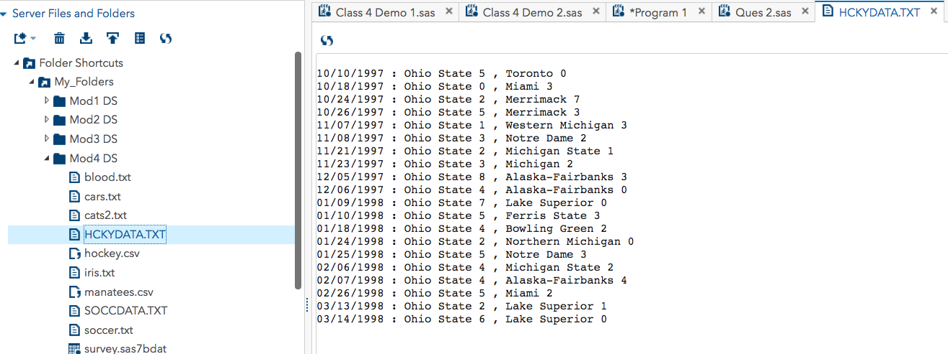

(Note: I am not able to insert the text copy of the output file HCKYDATA.TXT as I got some update issue with my MS Office. Therefore, I have attached the screenshot of the file below.)

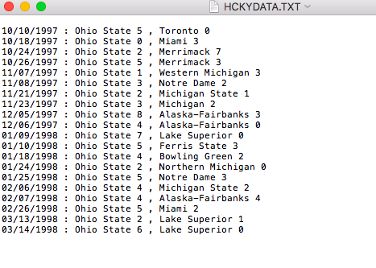

1. Refer to the MANATEES dataset. Write a SAS program which reads and prints the dataset. Provide labels for all of the variables, and print the dataset with the columns headed by those labels. Add a title and a footnote to the printout. Write at least one comment statement in your program.

Code:

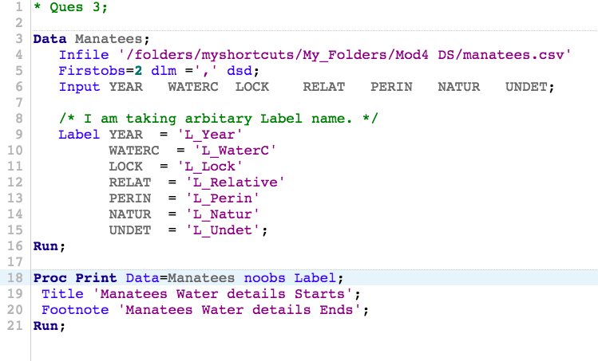

Log:

|  |
| --- |
| 1 OPTIONS NONOTES NOSTIMER NOSOURCE NOSYNTAXCHECK;  72  73 * Ques 3;  74  75 Data Manatees;  76 Infile '/folders/myshortcuts/My_Folders/Mod4 DS/manatees.csv'  77 Firstobs=2 dlm =',' dsd;  78 Input YEARWATERCLOCKRELATPERINNATURUNDET;  79  80 /* I am taking arbitary Label name. */  81 Label YEAR = 'L_Year'  82 WATERC = 'L_WaterC'  83 LOCK = 'L_Lock'  84 RELAT = 'L_Relative'  85 PERIN = 'L_Perin'  86 NATUR = 'L_Natur'  87 UNDET = 'L_Undet';  88 Run;    NOTE: The infile '/folders/myshortcuts/My_Folders/Mod4 DS/manatees.csv' is:  Filename=/folders/myshortcuts/My_Folders/Mod4 DS/manatees.csv,  Owner Name=root,Group Name=vboxsf,  Access Permission=-rwxrwx---,  Last Modified=01Mar2018:21:49:23,  File Size (bytes)=540    NOTE: 23 records were read from the infile '/folders/myshortcuts/My_Folders/Mod4 DS/manatees.csv'.  The minimum record length was 17.  The maximum record length was 23.  NOTE: The data set WORK.MANATEES has 23 observations and 7 variables.  NOTE: DATA statement used (Total process time):  real time 0.01 seconds  cpu time 0.02 seconds      89  90 Proc Print Data=Manatees noobs Label;  91 Title 'Manatees Water details Starts';  92 Footnote 'Manatees Water details Ends';  93 Run;    NOTE: There were 23 observations read from the data set WORK.MANATEES.  NOTE: PROCEDURE PRINT used (Total process time):  real time 0.09 seconds  cpu time 0.09 seconds      94  95 OPTIONS NONOTES NOSTIMER NOSOURCE NOSYNTAXCHECK;  108 |

Results:

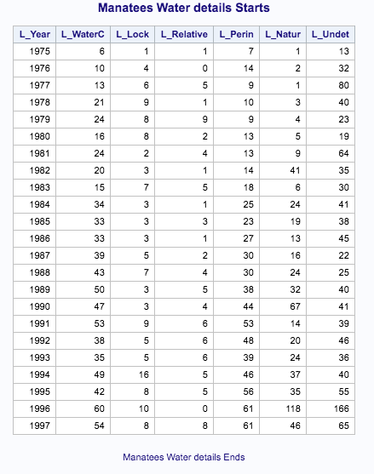

1. Refer to the USEDCARS dataset. Write a SAS program which reads the dataset and prints only the following information in this order:

* Year
* Manufacturer
* Model
* Mileage (printed as “<50,000”,”>=50,000”, or “Unknown”, depending on the numeric value of the mileage variable)
* Cost (printed as “Economy” if the price is under $5,000, “Moderate” if the price is between $5,000 and $10,000, or “Expensive” if the price is over $10,000).

Use FORMAT statements to print the mileage and cost variables. Write at least one comment statement in your program.

Code:

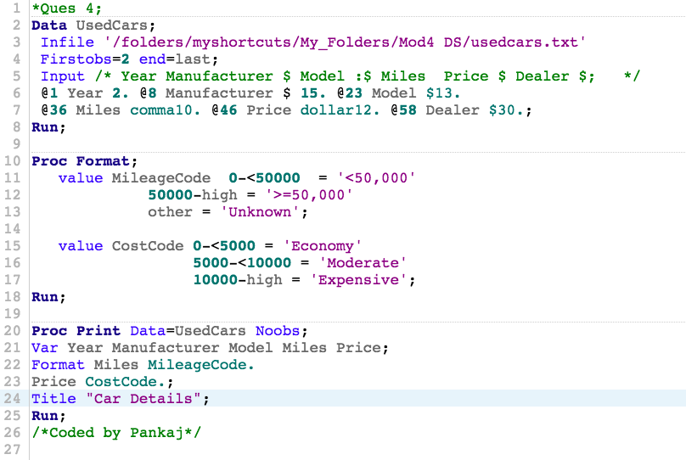

Log:

|  |
| --- |
| 1 OPTIONS NONOTES NOSTIMER NOSOURCE NOSYNTAXCHECK;  72  73 *Ques 4;  74 Data UsedCars;  75 Infile '/folders/myshortcuts/My_Folders/Mod4 DS/usedcars.txt'  76 Firstobs=2 end=last;  77 Input /* Year Manufacturer $ Model :$ Miles Price $ Dealer $; */  78 @1 Year 2. @8 Manufacturer $ 15. @23 Model $13.  79 @36 Miles comma10. @46 Price dollar12. @58 Dealer $30.;  80 Run;    NOTE: The infile '/folders/myshortcuts/My_Folders/Mod4 DS/usedcars.txt' is:  Filename=/folders/myshortcuts/My_Folders/Mod4 DS/usedcars.txt,  Owner Name=root,Group Name=vboxsf,  Access Permission=-rwxrwx---,  Last Modified=27Feb2018:11:41:55,  File Size (bytes)=4754    NOTE: Invalid data for Year in line 52 1-2.  NOTE: Invalid data for Miles in line 52 36-45.  NOTE: LOST CARD.  NOTE: Invalid data errors for file ''/folders/myshortcuts/My_Folders/Mod4 DS/usedcars.txt'' occurred outside the printed range.  NOTE: Increase available buffer lines with the INFILE n= option.  last=1 Year=. Manufacturer=Gainesville Su Model=n Classified Miles=. Price=. Dealer= _ERROR_=1 _N_=51  NOTE: 51 records were read from the infile '/folders/myshortcuts/My_Folders/Mod4 DS/usedcars.txt'.  The minimum record length was 51.  The maximum record length was 91.  NOTE: SAS went to a new line when INPUT statement reached past the end of a line.  NOTE: The data set WORK.USEDCARS has 50 observations and 6 variables.  NOTE: DATA statement used (Total process time):  real time 0.01 seconds  cpu time 0.00 seconds      81  82 Proc Format;  83 value MileageCode 0-<50000 = '<50,000'  84 50000-high = '>=50,000'  85 other = 'Unknown';  NOTE: Format MILEAGECODE is already on the library WORK.FORMATS.  NOTE: Format MILEAGECODE has been output.  86  87 value CostCode 0-<5000 = 'Economy'  88 5000-<10000 = 'Moderate'  89 10000-high = 'Expensive';  NOTE: Format COSTCODE is already on the library WORK.FORMATS.  NOTE: Format COSTCODE has been output.  90 Run;    NOTE: PROCEDURE FORMAT used (Total process time):  real time 0.00 seconds  cpu time 0.00 seconds      91  92 Proc Print Data=UsedCars Noobs;  93 Var Year Manufacturer Model Miles Price;  94 Format Miles MileageCode.  95 Price CostCode.;  96 Title "Car Details";  97 Run;    NOTE: There were 50 observations read from the data set WORK.USEDCARS.  NOTE: PROCEDURE PRINT used (Total process time):  real time 0.13 seconds  cpu time 0.12 seconds      98 /*Coded by Pankaj*/  99  100  101  102 OPTIONS NONOTES NOSTIMER NOSOURCE NOSYNTAXCHECK;  115 |

Results:

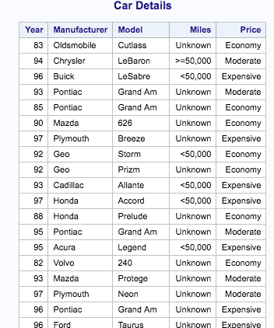

1. Refer to CATS2 dataset. Write a SAS program which reads the dataset and prints only the names of the cats and their GFR values at week 0, arranged in order from the smallest GFR value at week 0 to the largest. Write at least one comment statement in your program.

Code:

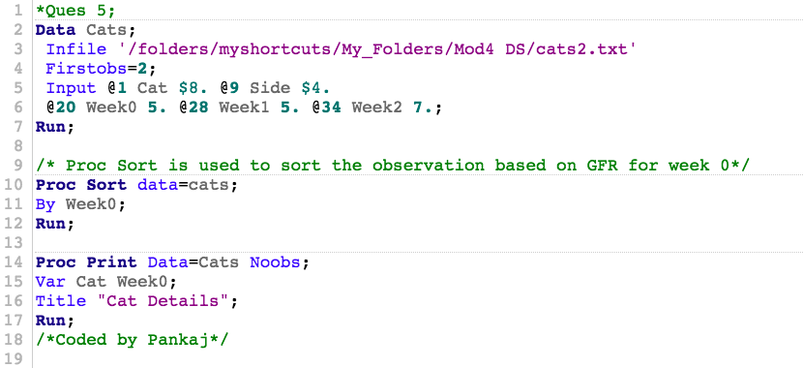

Log:

|  |
| --- |
| 1 OPTIONS NONOTES NOSTIMER NOSOURCE NOSYNTAXCHECK;  72  73 *Ques 5;  74 Data Cats;  75 Infile '/folders/myshortcuts/My_Folders/Mod4 DS/cats2.txt'  76 Firstobs=2;  77 Input @1 Cat $8. @9 Side $4.  78 @20 Week0 5. @28 Week1 5. @34 Week2 7.;  79 Run;    NOTE: The infile '/folders/myshortcuts/My_Folders/Mod4 DS/cats2.txt' is:  Filename=/folders/myshortcuts/My_Folders/Mod4 DS/cats2.txt,  Owner Name=root,Group Name=vboxsf,  Access Permission=-rwxrwx---,  Last Modified=27Feb2018:00:48:30,  File Size (bytes)=380    NOTE: 8 records were read from the infile '/folders/myshortcuts/My_Folders/Mod4 DS/cats2.txt'.  The minimum record length was 40.  The maximum record length was 40.  NOTE: The data set WORK.CATS has 8 observations and 5 variables.  NOTE: DATA statement used (Total process time):  real time 0.01 seconds  cpu time 0.01 seconds      80  81 /* Proc Sort is used to sort the observation based on GFR for week 0*/  82 Proc Sort data=cats;  83 By Week0;  84 Run;    NOTE: There were 8 observations read from the data set WORK.CATS.  NOTE: The data set WORK.CATS has 8 observations and 5 variables.  NOTE: PROCEDURE SORT used (Total process time):  real time 0.00 seconds  cpu time 0.01 seconds      85  86 Proc Print Data=Cats Noobs;  87 Var Cat Week0;  88 Title "Cat Details";  89 Run;    NOTE: There were 8 observations read from the data set WORK.CATS.  NOTE: PROCEDURE PRINT used (Total process time):  real time 0.06 seconds  cpu time 0.06 seconds      90 /*Coded by Pankaj*/  91  92  93  94 OPTIONS NONOTES NOSTIMER NOSOURCE NOSYNTAXCHECK;  107 |

Results:

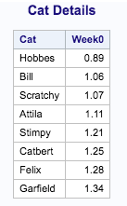

1. Refer to the HANKS dataset. Write a SAS program which reads the dataset and prints (in chronological order from 1984 to 1998) only the title of the movie, the year, and the simplified children’s rating system, as described below:

* MPAA rating of G = ”Suitable”
* PG or PG-13 = ”Questionable”
* R = ”Not Suitable”

Use FORMAT statements to print the ratings. Write at least one comment statement in your program.

Code:

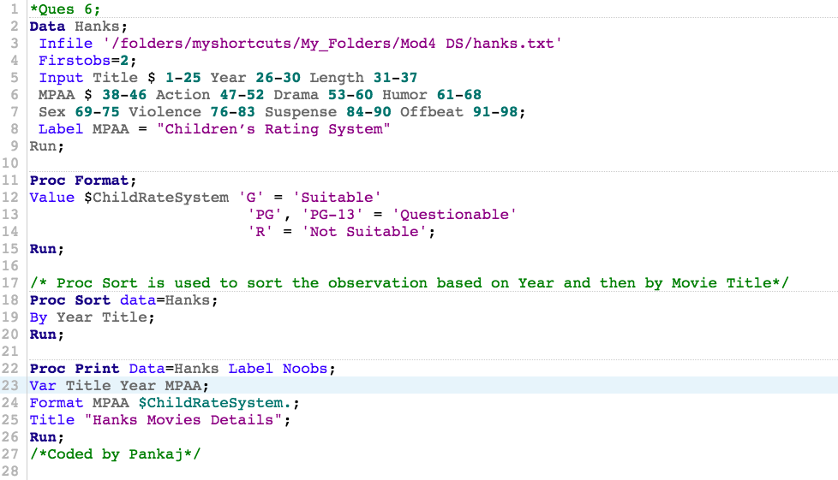

Log:

|  |
| --- |
| 1 OPTIONS NONOTES NOSTIMER NOSOURCE NOSYNTAXCHECK;  72  73 *Ques 6;  74 Data Hanks;  75 Infile '/folders/myshortcuts/My_Folders/Mod4 DS/hanks.txt'  76 Firstobs=2;  77 Input Title $ 1-25 Year 26-30 Length 31-37  78 MPAA $ 38-46 Action 47-52 Drama 53-60 Humor 61-68  79 Sex 69-75 Violence 76-83 Suspense 84-90 Offbeat 91-98;  80 Label MPAA = "Children’s Rating System"  81 Run;  82    NOTE: The infile '/folders/myshortcuts/My_Folders/Mod4 DS/hanks.txt' is:  Filename=/folders/myshortcuts/My_Folders/Mod4 DS/hanks.txt,  Owner Name=root,Group Name=vboxsf,  Access Permission=-rwxrwx---,  Last Modified=02Mar2018:02:11:28,  File Size (bytes)=2283    NOTE: 22 records were read from the infile '/folders/myshortcuts/My_Folders/Mod4 DS/hanks.txt'.  The minimum record length was 98.  The maximum record length was 98.  NOTE: The data set WORK.HANKS has 22 observations and 11 variables.  NOTE: DATA statement used (Total process time):  real time 0.01 seconds  cpu time 0.01 seconds    83 Proc Format;    84 Value $ChildRateSystem 'G' = 'Suitable'  85 'PG', 'PG-13' = 'Questionable'  86 'R' = 'Not Suitable';  NOTE: Format $CHILDRATESYSTEM is already on the library WORK.FORMATS.  NOTE: Format $CHILDRATESYSTEM has been output.  87 Run;    NOTE: PROCEDURE FORMAT used (Total process time):  real time 0.00 seconds  cpu time 0.01 seconds      88  89 /* Proc Sort is used to sort the observation based on Year and then by Movie Title*/  90 Proc Sort data=Hanks;  91 By Year Title;  92 Run;    NOTE: There were 22 observations read from the data set WORK.HANKS.  NOTE: The data set WORK.HANKS has 22 observations and 11 variables.  NOTE: PROCEDURE SORT used (Total process time):  real time 0.00 seconds  cpu time 0.00 seconds      93  94 Proc Print Data=Hanks Label Noobs;  95 Var Title Year MPAA;  96 Format MPAA $ChildRateSystem.;  97 Title "Hanks Movies Details";  98 Run;    NOTE: There were 22 observations read from the data set WORK.HANKS.  NOTE: PROCEDURE PRINT used (Total process time):  real time 0.07 seconds  cpu time 0.07 seconds      99 /*Coded by Pankaj*/  100  101  102  103 OPTIONS NONOTES NOSTIMER NOSOURCE NOSYNTAXCHECK;  116 |

Results:

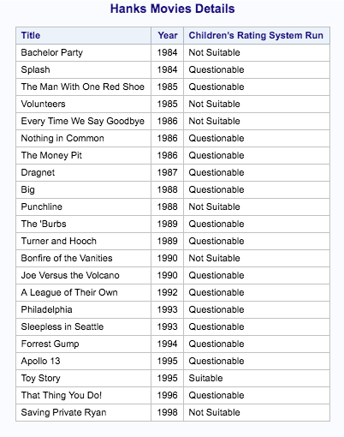

1. Refer to the IRIS dataset. Write a SAS program which reads the dataset and prints only the data for the 50 observations with the largest sepal widths. Label the variables and print those labels instead of the variable names. Write at least one comment statement in your program. (You should see from the printout that *setosa* tends to have the largest sepal widths.)

Code:

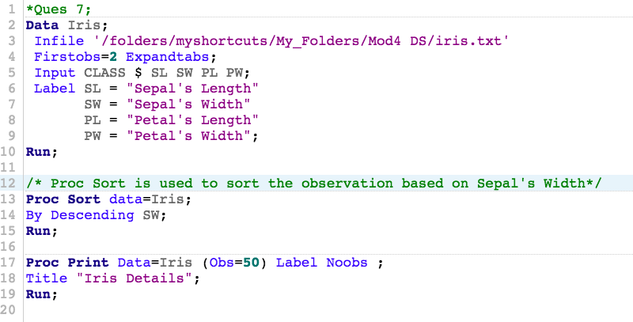

Log:

|  |
| --- |
| 1 OPTIONS NONOTES NOSTIMER NOSOURCE NOSYNTAXCHECK;  72  73 *Ques 7;  74 Data Iris;  75 Infile '/folders/myshortcuts/My_Folders/Mod4 DS/iris.txt'  76 Firstobs=2 Expandtabs;  77 Input CLASS $ SL SW PL PW;  78 Label SL = "Sepal's Length"  79 SW = "Sepal's Width"  80 PL = "Petal's Length"  81 PW = "Petal's Width";  82 Run;    NOTE: The infile '/folders/myshortcuts/My_Folders/Mod4 DS/iris.txt' is:  Filename=/folders/myshortcuts/My_Folders/Mod4 DS/iris.txt,  Owner Name=root,Group Name=vboxsf,  Access Permission=-rwxrwx---,  Last Modified=27Feb2018:00:48:46,  File Size (bytes)=6643    NOTE: 150 records were read from the infile '/folders/myshortcuts/My_Folders/Mod4 DS/iris.txt'.  The minimum record length was 42.  The maximum record length was 42.  NOTE: The data set WORK.IRIS has 150 observations and 5 variables.  NOTE: DATA statement used (Total process time):  real time 0.00 seconds  cpu time 0.00 seconds      83  84 /* Proc Sort is used to sort the observation based on Sepal's Width*/  85 Proc Sort data=Iris;  86 By Descending SW;  87 Run;    NOTE: There were 150 observations read from the data set WORK.IRIS.  NOTE: The data set WORK.IRIS has 150 observations and 5 variables.  NOTE: PROCEDURE SORT used (Total process time):  real time 0.00 seconds  cpu time 0.01 seconds      88  89 Proc Print Data=Iris (Obs=50) Label Noobs ;  90 Title "Iris Details";  91 Run;    NOTE: There were 50 observations read from the data set WORK.IRIS.  NOTE: PROCEDURE PRINT used (Total process time):  real time 0.11 seconds  cpu time 0.11 seconds      92  93  94 OPTIONS NONOTES NOSTIMER NOSOURCE NOSYNTAXCHECK;  107 |

Results:

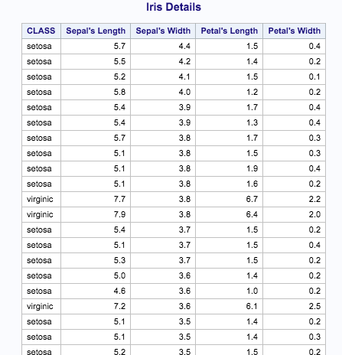

1. Refer to RYAN dataset. Write a SAS program which reads and prints the dataset. Now, run the same program, but insert these lines as the first two lines of the program:

options pageno=**385** missing='?' skip=**20** firstobs=**5** obs=**12**;

**run**;

Compare the two results and write an explanation of the functions performed by each of the five options. Turn in a copy of your SAS program statements, the “before” and “after” printouts, and your written explanations.

Note-To return your SAS session back to its normal options, submit the following two lines of SAS code:

options pageno=**1** missing='.' skip=**0** firstobs=**1** obs=MAX;

**run**;

Before the execution of the given line:

Code:

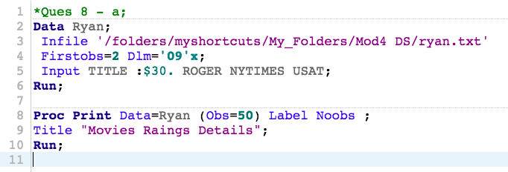

Log:

|  |
| --- |
| 1 OPTIONS NONOTES NOSTIMER NOSOURCE NOSYNTAXCHECK;  72  73 *Ques 8;  74 Data Ryan;  75 Infile '/folders/myshortcuts/My_Folders/Mod4 DS/ryan.txt'  76 Firstobs=2 Dlm='09'x;  77 Input TITLE :$30. ROGER NYTIMES USAT;  78 Run;    NOTE: The infile '/folders/myshortcuts/My_Folders/Mod4 DS/ryan.txt' is:  Filename=/folders/myshortcuts/My_Folders/Mod4 DS/ryan.txt,  Owner Name=root,Group Name=vboxsf,  Access Permission=-rwxrwx---,  Last Modified=02Mar2018:03:17:15,  File Size (bytes)=541    NOTE: 21 records were read from the infile '/folders/myshortcuts/My_Folders/Mod4 DS/ryan.txt'.  The minimum record length was 13.  The maximum record length was 32.  NOTE: The data set WORK.RYAN has 21 observations and 4 variables.  NOTE: DATA statement used (Total process time):  real time 0.01 seconds  cpu time 0.01 seconds      79  80 Proc Print Data=Ryan (Obs=50) Label Noobs ;  81 Title "Movies Raings Details";  82 Run;    NOTE: There were 21 observations read from the data set WORK.RYAN.  NOTE: PROCEDURE PRINT used (Total process time):  real time 0.07 seconds  cpu time 0.06 seconds      83  84  85 OPTIONS NONOTES NOSTIMER NOSOURCE NOSYNTAXCHECK;  98 |

Results:

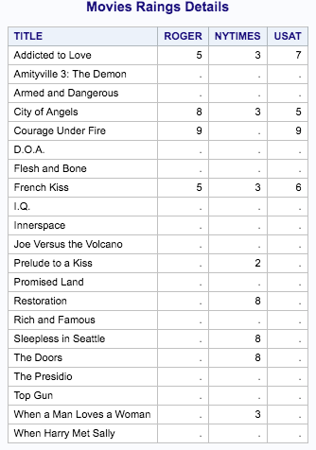

After the execution of the given code:

Code:

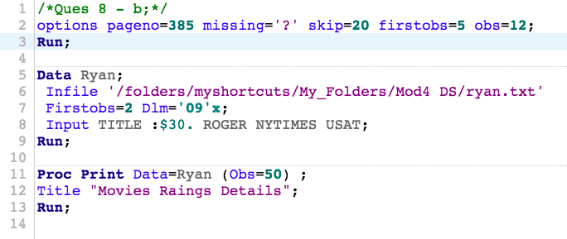

Log:

|  |
| --- |
| 1 OPTIONS NONOTES NOSTIMER NOSOURCE NOSYNTAXCHECK;  72  73 /*Ques 8 - b;*/  74 options pageno=385 missing='?' skip=20 firstobs=5 obs=12;  75 Run;  76  77 Data Ryan;  78 Infile '/folders/myshortcuts/My_Folders/Mod4 DS/ryan.txt'  79 Firstobs=2 Dlm='09'x;  80 Input TITLE :$30. ROGER NYTIMES USAT;  81 Run;    NOTE: The infile '/folders/myshortcuts/My_Folders/Mod4 DS/ryan.txt' is:  Filename=/folders/myshortcuts/My_Folders/Mod4 DS/ryan.txt,  Owner Name=root,Group Name=vboxsf,  Access Permission=-rwxrwx---,  Last Modified=02Mar2018:03:17:15,  File Size (bytes)=541    NOTE: 11 records were read from the infile '/folders/myshortcuts/My_Folders/Mod4 DS/ryan.txt'.  The minimum record length was 13.  The maximum record length was 30.  NOTE: The data set WORK.RYAN has 11 observations and 4 variables.  NOTE: DATA statement used (Total process time):  real time 0.01 seconds  cpu time 0.01 seconds      82  83 Proc Print Data=Ryan (Obs=50) ;  84 Title "Movies Raings Details";  85 Run;    NOTE: There were 7 observations read from the data set WORK.RYAN.  NOTE: PROCEDURE PRINT used (Total process time):  real time 0.08 seconds  cpu time 0.08 seconds      86  87  88 OPTIONS NONOTES NOSTIMER NOSOURCE NOSYNTAXCHECK;  101 |

Results:

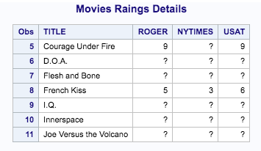

: Options pageno=385 :- This provides instruction as the beginning of the next page number for the SAS output produced. Note that it should be reset to 0 before starting another program for a given SAS session.

: Options missing='?' :– This command replaces the missing value notation of default “.” to “?”.

: Options skip=20 :- This is of help when we want to print the output results. Usually in the printer, the first line of the new pages as skipped few lines to print afresh. This is usually done by the skip instruction. If the print place is correctly coded then there is no need to skip these lines. The values for skip ranges from 0-20.

: Options firstobs=5 & obs=12 :– This commands Sas to start the output observation from 5th row and will capture till (12th -1) Observation i.e. excluding 12th row.

Source:- http://support.sas.com/documentation

1. Run the following program to create a SAS data set called Colors

**data** colors;

input Color : $1. @@;

datalines;

R R B G Y Y . . B G R B G Y P O O V V B

;

Use a format to group the colors as follows:

R, G, B = Group 1

Y, O = Group 2

Missing = Not Given

All others = Group 3

Use PROC FREQ to list the frequencies of the color groups.

Code:

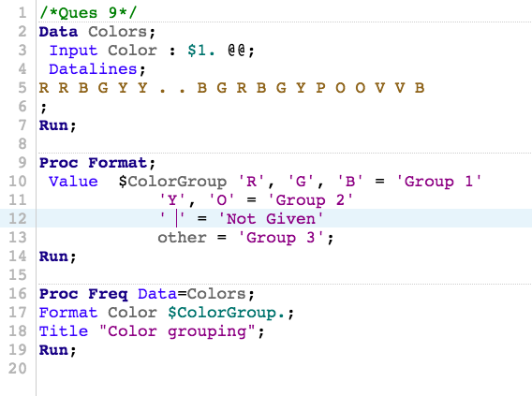

Log:

|  |
| --- |
| 1 OPTIONS NONOTES NOSTIMER NOSOURCE NOSYNTAXCHECK;  72  73 /*Ques 9*/  74 Data Colors;  75 Input Color : $1. @@;  76 Datalines;    NOTE: SAS went to a new line when INPUT statement reached past the end of a line.  NOTE: The data set WORK.COLORS has 20 observations and 1 variables.  NOTE: DATA statement used (Total process time):  real time 0.00 seconds  cpu time 0.00 seconds    78 ;    79 Run;  80  81 Proc Format;  82 Value $ColorGroup'R', 'G', 'B' = 'Group 1'  83 'Y', 'O' = 'Group 2'  84 ' ' = 'Not Given'  85 other = 'Group 3';  NOTE: Format $COLORGROUP is already on the library WORK.FORMATS.  NOTE: Format $COLORGROUP has been output.  86 Run;    NOTE: PROCEDURE FORMAT used (Total process time):  real time 0.00 seconds  cpu time 0.00 seconds      87  88 Proc Freq Data=Colors;  89 Format Color $ColorGroup.;  90 Title "Color grouping";  91 Run;    NOTE: There were 20 observations read from the data set WORK.COLORS.  NOTE: PROCEDURE FREQ used (Total process time):  real time 0.06 seconds  cpu time 0.07 seconds      92  93  94 OPTIONS NONOTES NOSTIMER NOSOURCE NOSYNTAXCHECK;  107 |

Results:

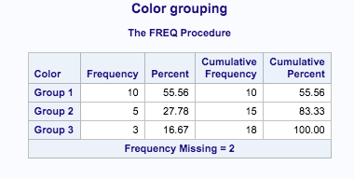

1. Write the necessary statements to make three permanent formats in a library of your choice. Use the FMTLIB option to list each of these formats. The formats are defined as follows:

YESNO 1=Yes, 0=No

$YESNO Y=Yes, N=No

$Gender M=Male, F=Female

Age20yr low-20 = 1, 21-40=2, 41-60=3, 61-80=4, 81-high=5.

Code:

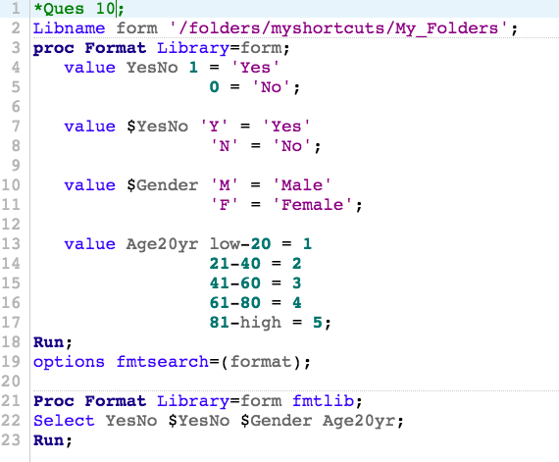

Log:

|  |
| --- |
| 1 OPTIONS NONOTES NOSTIMER NOSOURCE NOSYNTAXCHECK;  72  73 *Ques 4;  74 Libname form '/folders/myshortcuts/My_Folders';  NOTE: Libref FORM refers to the same physical library as MYFORMAT.  NOTE: Libref FORM was successfully assigned as follows:  Engine: V9  Physical Name: /folders/myshortcuts/My_Folders  75 proc Format Library=form;  76 value YesNo 1 = 'Yes'  77 0 = 'No';  NOTE: Format YESNO is already on the library FORM.FORMATS.  NOTE: Format YESNO has been written to FORM.FORMATS.  78  79 value $YesNo 'Y' = 'Yes'  80 'N' = 'No';  NOTE: Format $YESNO is already on the library FORM.FORMATS.  NOTE: Format $YESNO has been written to FORM.FORMATS.  81  82 value $Gender 'M' = 'Male'  83 'F' = 'Female';  NOTE: Format $GENDER is already on the library FORM.FORMATS.  NOTE: Format $GENDER has been written to FORM.FORMATS.  84  85 value Age20yr low-20 = 1  86 21-40 = 2  87 41-60 = 3  88 61-80 = 4  89 81-high = 5;  NOTE: Format AGE20YR is already on the library FORM.FORMATS.  NOTE: Format AGE20YR has been written to FORM.FORMATS.  90 Run;    NOTE: PROCEDURE FORMAT used (Total process time):  real time 0.01 seconds  cpu time 0.00 seconds      91 options fmtsearch=(format);  92  93 Proc Format Library=form fmtlib;  94 Select YesNo $YesNo $Gender Age20yr;  95 Run;    NOTE: PROCEDURE FORMAT used (Total process time):  real time 0.05 seconds  cpu time 0.05 seconds      96  97 OPTIONS NONOTES NOSTIMER NOSOURCE NOSYNTAXCHECK;  110 |

Results:

